**Practical No: 2** Ninad Karlekar 22306A1012 Date: 13/03/2023

**Aim: Implementation of BGP using AS_path attribute.**

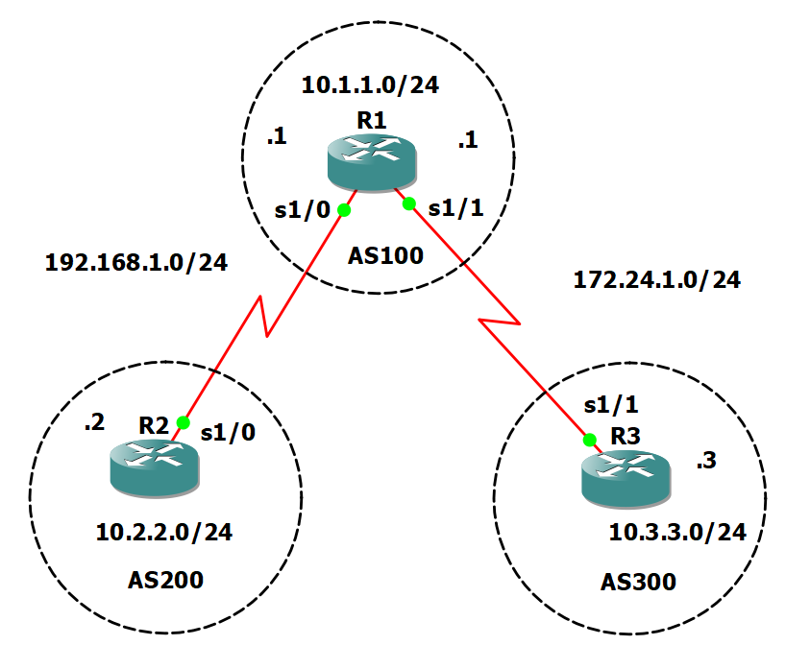

Take 3 routers -> Configure -> slots -> NM-4T

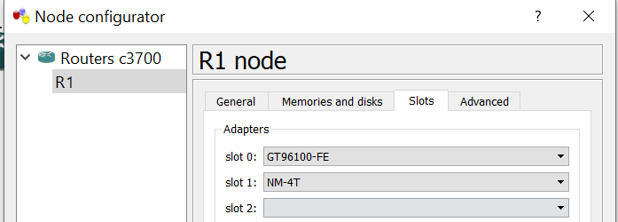

**On Router console type following commands one by one.**

**R1 Console**

conf t

int s1/0

ip add 192.168.1.1 255.255.255.0

no sh

int s1/1

ip add 172.24.1.1 255.255.255.0

no sh

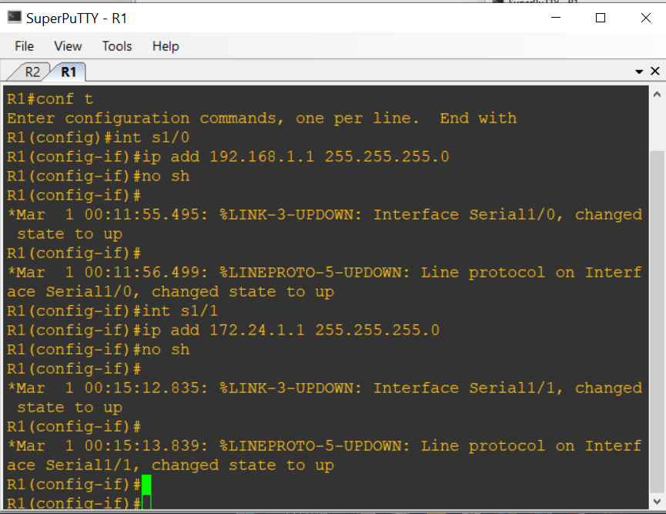

**R2 Console**

conf t

int s1/0

ip add 192.168.1.2 255.255.255.0

no sh

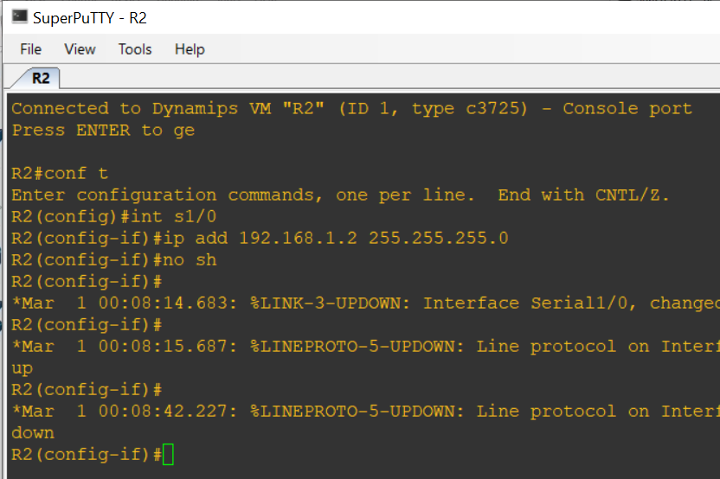

**R3 Console**

conf t

int s1/1

ip add 172.24.1.3 255.255.255.0

no sh

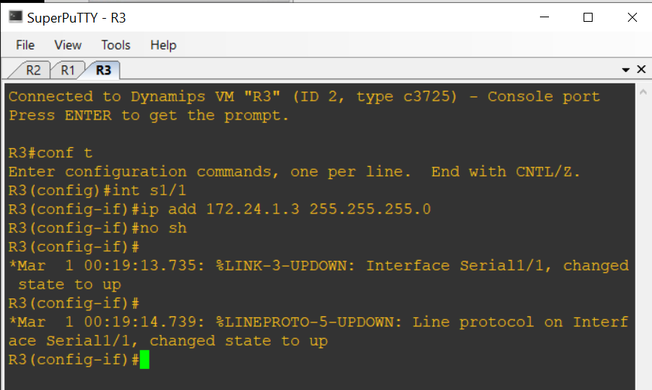

**To add loopback address ,On Router console type following commands one by one.**

**R1 Console**

int lo0

ip add 10.1.1.1 255.255.255.0

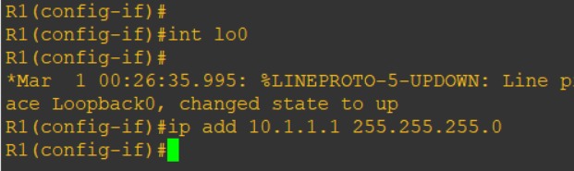

**R2 Console**

int lo0

ip add 10.2.2.2 255.255.255.0

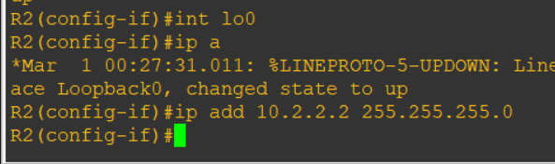

**R3 Console**

int lo0

ip add 10.3.3.3 255.255.255.0

**To add bgp protocol, On Router console type following commands one by one.**

**R1 Console**

router bgp 100

neighbor 192.168.1.2 remote-as 200

neighbor 172.24.1.3 remote-as 300

network 10.1.1.0 mask 255.255.255.0

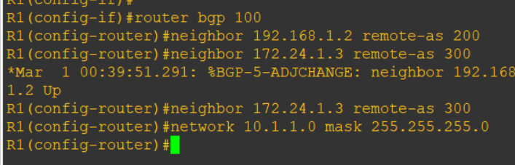

**R2 Console**

router bgp 200

neighbor 192.168.1.1 remote-as 100

network 10.2.2.0 mask 255.255.255.0

**R3 Console**

router bgp 300

neighbor 172.24.1.1 remote-as 100

network 10.3.3.0 mask 255.255.255.0

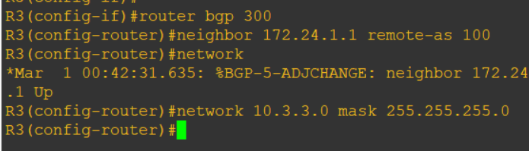

**To show ip route type following command in each router console**

do sh ip route

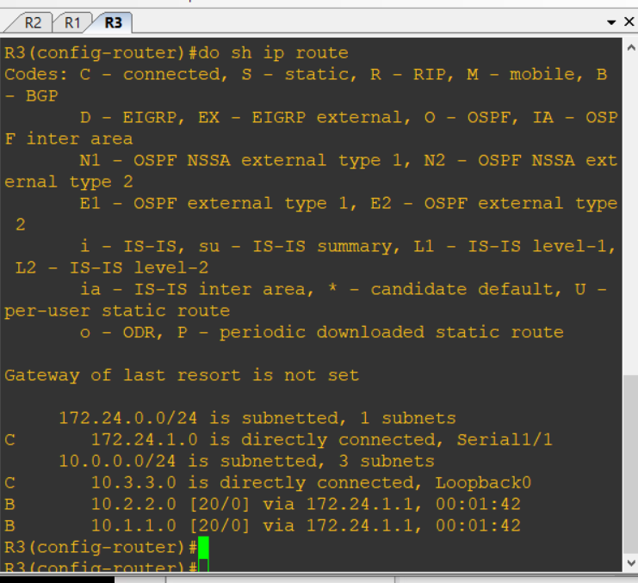

**To verify output type following commands: (OUTPUT)**

do ping 10.3.3.3 source lo0

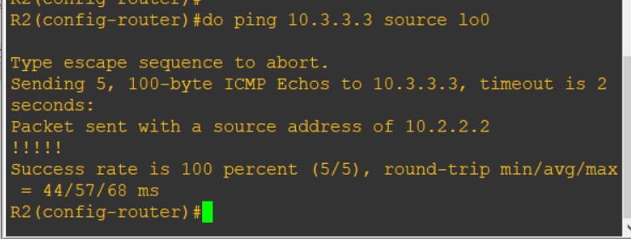

do ping 10.2.2.2 source lo0

